User1 Testing report

Scope of testing
User1 signed up with a real work email on a work computer with a real data cleaning and processing scenario. Two types of tests were undertaken: 1. Select all three options and brief the dataset information via filling a form; 2. Select the first option, Diagnose problems in my dataset and standardise its format, and brief the dataset information via uploading a dummy dataset.

Test 1:

User action | Results | Description
User1 signed up with work email | Proceeded
User1 edited profile | Failed | “edit profile” did not react
User1 started a new task | Proceeded
Selected all three options | Proceeded
Filled general information | Proceeded
Filled in a form | Proceeded but | Gaps discovered for optimisation:  Human errors cannot be corrected, for example, deleted a column by mistake but couldn’t recover, spelling mistakes couldn’t be edited by user
Filled in Cross-Column Checks | Proceeded but | Gaps discovered for optimisation:  Column to row transformation is not considered (screen shoot 1)
Filled in Link Datasets | Proceeded
Confirmed tasks | Proceeded with error messages | screen shoot 2

Test 2:
User action | Results | Description
User1 logged in with work email | Proceeded
User1 started a new task | Proceeded
Selected first option | Proceeded
Uploaded a dummy excel file | Failed | - Failed discover the file type: user must select all files to see the targeted Excel file in the list  - Garbled text returned as the column information (screen shoot 3)

Screen shoot 1:
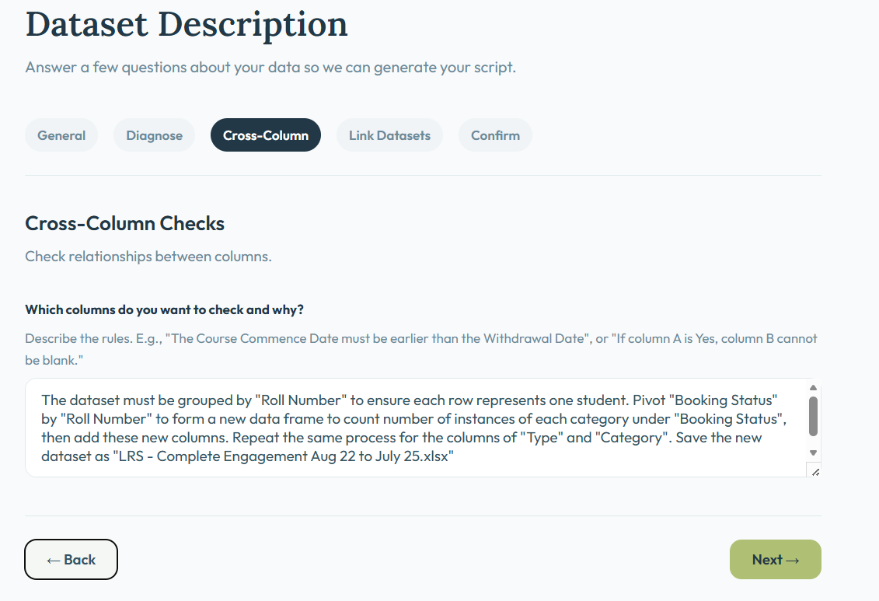

screen shoot 2

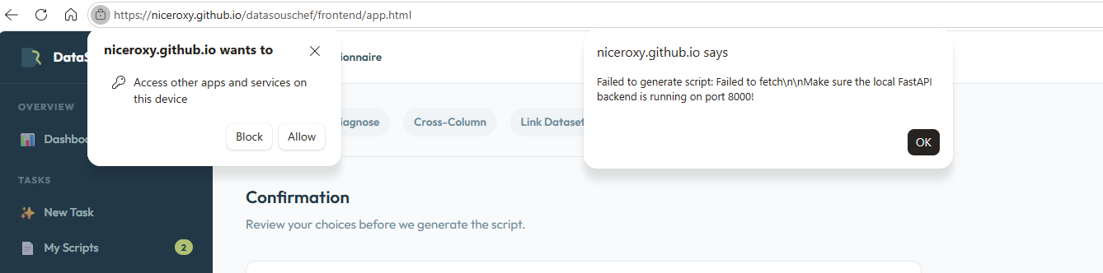

screen shoot 3
